Creative Arts Activities Grid 4
Below, you will find some creative activities that you can try on your own or with your family. Keep track of which activities you have tried!
Have fun! You can choose from anywhere on the grid, no matter what your year level. The choice is yours.

 | Visual Art | Drama/Dance | Music
_{K - PP} | 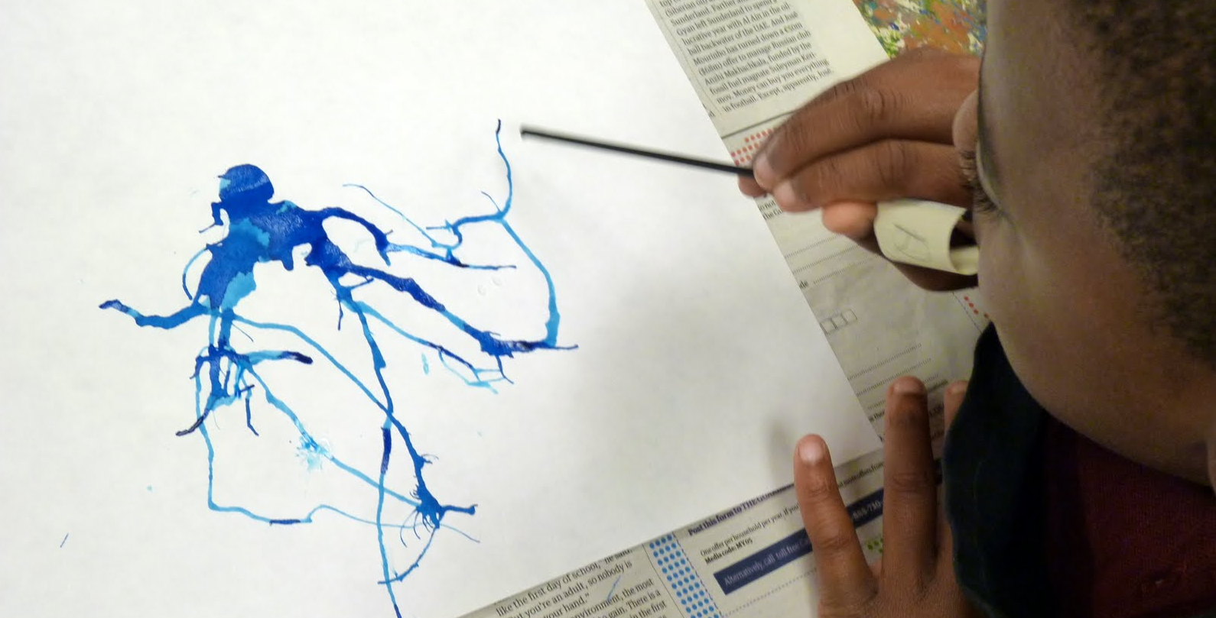  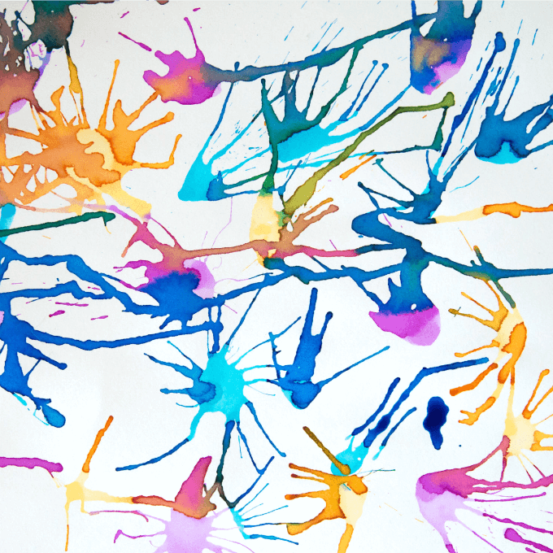  Blow Painting  - Mix liquid watercolours or food dye in individual cups with water.  - Place a piece of paper on a tray.  - Place the straw in a one of the liquid watercolour cups. Now place your fingertip over the top of the straw and lift up without removing your finger.  - Place the straw over your paper and let go. The paint will drop onto the paper.  - Place the straw near the drop of paint and blow to move the paint around.  - Repeat with more colours. | _{Circus Clown}  _{Watch this circus magic show}  https://www.youtube.com/watch?v=nmWhEZ0HSjM  Dress up like a clown by putting on some funny clothes. Give yourself a crazy hairstyle. Maybe you can make a hat or paint your face.  _{View}  https://www.youtube.com/watch?v=OP6U5LBqA9A  Now play the song again and follow the actions. Play the song one more time and make up your own circus actions. Use some scarves and put on a clown show for your family.  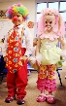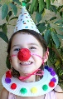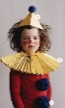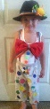 | The Way I Feel Today!  This is a wonderful song about the way you feel today. The song is about being happy! You might feel happy today, or you might be able to think of your own feeling that you can put into the song. It is presented by our Western Australian Symphony Orchestra for families.  https://www.waso.com.au/education-community/families/activities-for-families/
 | _{Egg Carton Face}  Use an egg carton to create a 3D portrait. Follow the link below but try to be even more creative by adding original details. You could even try to add an egg carton or box body! http://krokotak.com/2019/08/egg-carton-portraits/ | _{Can’t Stop the Feelings}  View and listen to this story about feelings https://www.youtube.com/watch?v=xIfLgHBwYx4  Have you ever felt happiness, sadness, bravery, anger or shyness. How do you show these feelings?  Sing a long with the Wiggles  https://www.youtube.com/watch?v=Fa9Kv-fFKB0  Make up your own words and actions to the song. For example  If you’re happy and you know it, smile wide.  If you’re excited and you know it, jump up high.  If you’re tired and you know it, time to yawn.  If you’re angry and you know it, stamp your feet.  Dance to this happy song from Trolls  https://www.youtube.com/watch?v=oWgTqLCLE8k | Looking Up!  https://www.youtube.com/watch?v=Lrd0TiER_J0  Sing a long to this beautiful song about all of the wonderful things that are up in the air. If the weather is fine, take a rug or mat outside, look up in the air. What are all of the things that you can see up in the air?
₁ ₋ ₃ | Paper Craft For You…  Complete the craft activity on the link. You may decide to write a message on the person and give it to someone you love.  http://krokotak.com/2019/01/for-you/ | George’s Marvelous Medicine. Sing along with this funny song then make some dramatic actions to go with the words.  https://www.youtube.com/watch?v=-NvwiniH_c4 | Draw the Music  Listen to George’s Marvelous Medicine Piano Track https://www.youtube.com/watch?v=-zYgz2LaaWs  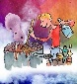  Now listen again and draw how the music makes you feel. Draw different lines and shapes depending on the tempo in the song.
 | Egg Carton Sea Creatures  Use egg cartons, paper, cardboard and other craft materials that you can find at home to create a variety of sea creatures. Then create an underwater world by making shells, coral and seaweed. You can use recycled materials, craft resources or found objects. Take a photo of your finished product.  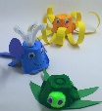 | One Word Story  Create a group story in this imaginative activity. The family or group sit or stand together  - Establish who will begin the story and which direction the story will travel (clockwise or anti-clockwise).  - The first person begins the story by saying a single word e.g. “There”.  - Whoever is next in the circle says another single word that makes sense following the previous word e.g. “was”.  - Continue around the circle, with each person saying a single word with the aim of building a coherent story | _{Under The Sea}  View and sing-a-long to “Under The Sea”  https://www.youtube.com/watch?v=Fkusy4ylhiY  Make your own percussion instrument (rice in a container, tapping sticks) Join in with this percussion ensemble.  https://www.youtube.com/watch?v=j9Dx8WP8YD4&list=RD6Q5N1DfzGj0&index=7  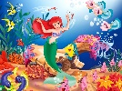
₄ ₋ ₆ | Creative Drawing Using Everyday Objects  Christoph Neiman is a contemporary German born visual artist. View some of his art here -  https://www.youtube.com/watch?v=9O9Eo5Laniw&app=desktop  You are challenged to find an object and transform it into something unrelated to the object.  You can find more inspiration through this link. https://www.youtube.com/watch?v=kjWDSq5FwM8&app=desktop  When you have finished your drawing take a photo  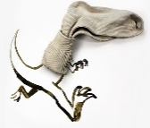 | Mirror, Mirror  - Pair up with a family member  - Decide who will be A, and who will be B.  - A begins to move very slowly.  - B has to copy the movement exactly as if they are the reflection A sees in a mirror.  - Continue for some time, and then swap, having B lead t A.  Move slowly, with the aim being that anyone watching the pair wouldn’t be able to tell who is leading the movement and who is following.  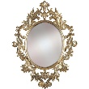 | Get to Know Musical Landscape!  What makes the music of Star Wars so iconic? Watch and learn from this fascinating clip from ABC music education.  https://education.abc.net.au/home#!/media/3405132/what-makes-the-music-of-star-wars-so-iconic
 | Find out about French artist George Seurat  https://www.youtube.com/watch?v=rDW4wSTm-V4  View this close up video of Seurat’s painting “The Circus”https://www.youtube.com/watch?v=6s7vb7irpiw  Now click this link to The Met Museum  https://www.metmuseum.org/art/online-features/metkids/explore/437654  Read the information and answer the questions about George Seurat’s “Circus Sideshow”. Now design your own circus poster. You may like to experiment with coloured dots.  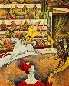 | Clowning Around  Watch these fun fact about clowns. https://www.youtube.com/watch?v=cIb7tnP755Q  Create a clown costume using clothing and resources you have at home.  Watch the following link to learn how to juggle  https://www.youtube.com/watch?v=QxzSHRbLAx4  Practice juggling and when you you have mastered it put on a performance for your family.  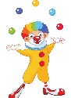 | Anthems!  https://www.youtube.com/watch?v=Atnfu_lzkM4  Which sports team do you support? Find their club song and find out how they came to choose that melody and the lyrics. Which other club song do you like to sing? What is it about a club anthem that brings the crowd together?  Can you write an anthem for your club? If you are not in a sports club, you can create an anthem for your family! What animal or bird would you use as a mascot?

